**Design Document**

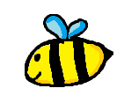Compulsion loop:

This game is a 2d ‘find and click’ game. Players have to dig for through the honeycomb to find *Honey Clumps* and *Coins* in order to progress.

Activity

Digging Honey

Rewards

Gaining coins and honey

Anticipation

Tool Upgrades for faster digging

Players can then make up jars of honey to build up their shop. Players can sell a jar of honey every day (fixed interval schedule) in order to get more coins.

Players can use the coins they gain to buy more bees to make the honeycomb size larger or upgrading their dig speed/strength.

